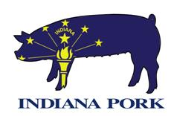

Indiana Pork Board of Directors Meeting Agenda
Friday June 4, 2021
**In Person**
8425 Keystone Crossing, First Floor Conference Room
9:00am until 3:00pm

- 9:00 am Call to Order (Checkoff Meeting) Brian Martin
- Welcome, Introductions, Conflict Policy, Antitrust Statement
- NPPC Funding Discussion Heather Hill, Jeb Stevens, Danita Rodibaugh, and Mark Legan
- Review of April Financials Tim Murphy
- 2021 Budget discussion
- Delegates and travel expenses for SHIP pilot project
- State Fair Update
- Other Business
- Adjourn Checkoff Meeting

- Call to Order (Non Checkoff Meeting) Brian Martin
- Disclosure Non Rule Policy at IDEM
- Zoning guide update
- Right to Farm Constitutional Amendment
- Home Based Vendor working group
- Other Business
- Adjourn

- 1:00pm Purdue Presentations
- Dr. Stacy Zuelly, Purdue Animal Sciences, Meat Science
  - Update on Meat Science programs/activities at Purdue
- Dr. John Blanton, Purdue Animal Sciences, Department Head
  - General introduction and discussion with Board

